Questioning a Text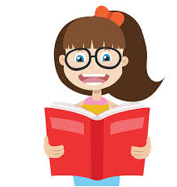
Decoding and Retrieval  Where did the story take place?  What do the characters look like?  Who spoke to …?  How was the …. described?  What does the character pick up/have in their pocket? | Infer and Deduce  Why is … important?  How do we know that…?  What do you think will have because of…?  What do you think will happen next?  What were the motives behind? | Structure and Organisation  How is this writing set out?  Which words tell you the order of events?  What is the main idea of this paragraph?  How does the layout help you understand what is written?
Language  What does this word/phrase mean?  How has the author shown that a character is happy/sad/angry?  How does the repetition in this paragraph help the description?  How do you know this is a formal/informal piece of writing? | The Writer  Why did the author choose to set the story here?  What impression of the character do you get?  Name a similar story that has this sort of timeline e.g flashbacks, dreams, concurrent stories.  How is the writing persuasive? | The Text and the World  What difference does the culture of the writing make to the story?  Can you think of a similar story from a different culture?  How have the author and illustrator worked together to help the story?  What would you need to know / what research would you need before writing this?

