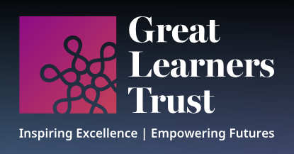
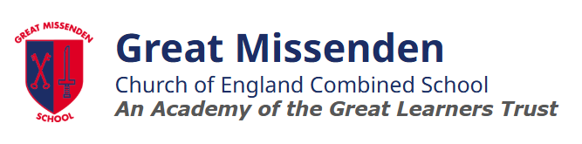
Art
Curriculum Subject

Intent:
At Great Missenden School, our intent for Art and Design is to nurture creativity, self-expression, and critical thinking in all students. We aim to provide a rich and diverse curriculum that encourages children to explore a wide range of artistic styles, cultures, and techniques, fostering an appreciation of art in its many forms. Through hands-on experiences and the study of diverse artists, we strive to develop pupils’ skills and confidence, enabling them to express their own ideas and emotions through art. Our goal is to inspire a lifelong love of creativity, empowering every child to see the world with a curious and imaginative mind.

Implementation:
- At Great Missenden, we prioritise high-quality teaching and learning in Art and Design through a progressive curriculum from Pre-school to Year 6. Art is taught as part of our termly WAC topics, with equal importance given to it as core subjects, in line with the National Curriculum. Each child has a sketchbook from Year 1 to track their artistic growth, develop techniques, and explore various materials.
- The children will have chance to develop their techniques, including their control and their use of a range of materials, with creativity, experimentation and an increasing awareness of different kinds of art, craft and design. Children will also know how art and design both reflect and shape our history, and contribute to the culture, creativity and wealth of our nation.
- Our students study a diverse range of artists from different genders, backgrounds, and cultures, fostering a broad understanding of how art shapes and reflects our history and society. Art Days are held to celebrate and showcase the children’s skills and progress.

Impact:
To truly understand the impact of our Art curriculum, you need to visit us and see it in action!
We measure impact through clear project end points and assessment criteria used by staff, ensuring they know the expectations for all children. Formative assessment is a key part of every Art lesson, guiding short-term planning and tracking progress.
At Great Missenden, our pupils are Artists. They love exploring the shapes, colours, and textures of the world around them, and are passionate about celebrating diverse cultures. They confidently express their views on global issues.
Our children leave Great Missenden with a deeper understanding of the world. They are equipped to challenge cultural stereotypes and inspired to make positive changes in the world they live in.

