
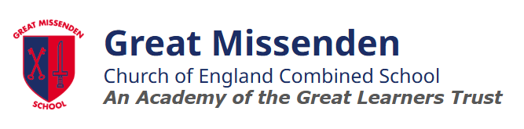
Phonics
Curriculum Subject

Curriculum Intent
At Great Missenden School, we believe that all our children can become fluent readers and writers. This is why we teach reading through the Little Wandle Letters and Sounds Revised programme, which is a systematic and synthetic phonics programme. We start teaching phonics in EYFS and follow the Little Wandle programme, which ensures children build on their growing knowledge of the alphabetic code, mastering phonics to read and spell as they move through school.
As a result, all our children can tackle any unfamiliar words as they read. At Great Missenden School, we also model the application of the alphabetic code through phonics in shared reading and writing, both inside and outside of the phonics lesson and across the curriculum. We have a strong focus on language development for our children because we know that speaking and listening are crucial skills for reading and writing in all subjects.

Implementation
Foundations in Pre-school
- Blend of child-led and adult-led activities supporting Communication and Language.
- Focus on high-quality stories, nursery rhymes, and activities for listening, attention, and oral blending.
- Preparing children for grapheme-phoneme correspondences (GPCs) and blending in Reception.

Daily Phonics in Reception and Year 1
- 30-minute phonics lessons daily (starting with shorter sessions in Reception).
- Reception: Begin teaching in Week 2 of Autumn term, covering Phase 2, 3, and 4 GPCs.
- Year 1: Review Phases 3 and 4, focus on Phase 5 GPCs.

Keep-up Lessons for Struggling Readers
- Daily support for children needing extra practice, following class structure with smaller steps.
- Pupils in Year 2 and beyond who have not yet secured the necessary phonic knowledge continue to receive systematic, targeted phonics teaching based on precise assessment of their gaps.

Reading Practice Sessions
- Small group reading practice three times a week with a trained adult.
- Sessions focus on decoding, prosody (expression), and comprehension.
- Reception starts in Week 4, and children who need help with decoding get additional blending practice.

Home Reading
- Children take home decodable books for practice and separate books for reading pleasure.

Support for Vulnerable Children
- Daily reading practice for children receiving additional phonics support.

Ensuring Consistency
- All staff follow the same teaching approach, using common resources and routines.
- Progress is monitored through regular assessments and observations.

Impact
Our phonics programme has made a significant difference to children’s reading skills, enjoyment, and overall access to the curriculum. As children’s decoding and fluency have improved, they are now better able to access learning across all subjects, not just English.
Students engage enthusiastically in structured, high-quality phonics lessons and have grown into more confident, expressive readers. This increased confidence has led to greater independence, improved comprehension, and stronger reading fluency.
Over the past two years, our phonics screening check pass rates have continued to rise, demonstrating the clear impact and effectiveness of the programme. Importantly, children are not only becoming more skilled readers but are also developing a genuine and lasting love of reading.

